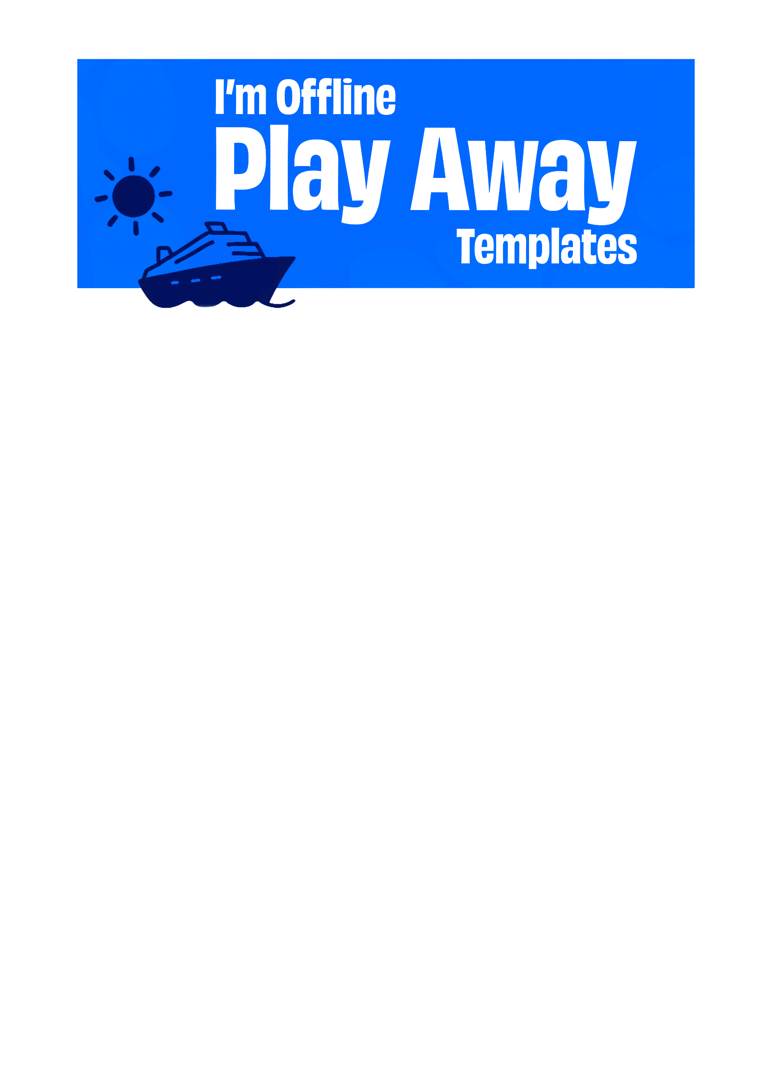
Got Someone That Needs a Reply ASAP? Grab From the Categories Below:
Slack & Teams
1. Currently OOO! Call you when I’m done playing. Or when I remember where I put my phone… Either one.
2. I’ve checked out of work mode and into play mode. See you when I’m back! ☀️
3. I’m off for a day of play to recharge and have some fun. Let’s catch up on [insert date]!
4. BRB. Gone to find myself. If found, I return on [insert date].
Email auto-replies
1. Currently out of office and off the tools for the day. If it can wait, I’ll catch it when I’m back. If not, [insert name] has you covered.
2. Hello! I’m away today for a well-earned play day. I’ll pick this up when I return on [insert date]. Thanks for your patience.
3. Hi, I’m out of the office today. Treating myself to a “less work, more play” kinda day. Let’s chat when I’m back on [insert date].
4. Hello, my inbox and I are taking some time apart while I’m off in search of fun. We’ll reconnect on [insert date].
Text messages for friends & family
1. Catch you on the flip side! Or whatever the kids say nowadays 🤪…I’m off having a play day. I'll call you when I’m back.
2. Taking a proper day off and ignoring my phone for once. You know you want to, too… Go on, give it a try. Promise I’ll text you back when playtime is over!
3. BRB, my phone’s on silent to help me focus on fun! Catch ya later, alligator. (I may respond to animal puns or witty banter – my phone is a Fun Only Zone today) 🐊
4. Hold the phone! I’m taking the day off. Doctor’s orders (doctor has prescribed a healthy dose of playtime. Doctor is me).

